Blessings to you! Thank you for your patience.
In case you didn’t see them, first of all here are the promo videos that are filled with teaching… in addition to the actual links for the classes themselves which are in audio form
https://vimeo.com/145736841
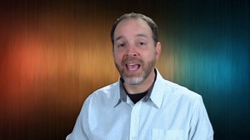 | WHATEVER IS TRUE OF JESUS IS TRUE OF YOU: YOUR UNSHAKABLE ...  vimeo.com  Discover YOUR unshakable Gospel and how the finished work of Christ means that he did it all. Includes a 6 minute cartoon-marker board type clip that clearly explains…
https://vimeo.com/144588421
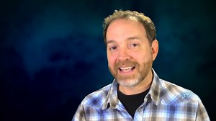 | Unshakable Gospel, What Was Jesus Doing in Hades 3 Days  vimeo.com  Do you know? The answer is life-transforming. For the other amazing videos please go to www.UnshakableGospel.com/home
https://vimeo.com/144254989
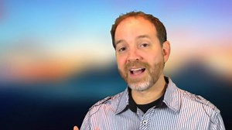 | Unshakable Gospel: Transformation Made Easy  vimeo.com  Transformation Made Easy. Have you tried dozens of different methods to help bring change in your life. Change means you are trying to become someone you aren't ...

Here are the links for each lesson, plus the notes and the bonus material and "The Father's Perfect Love For You".
You will need to right click, then save as, so that you are downloading each file. This way it will be on your computer, instead of simply playing it directly from the site.
Also, since these links are the direct links to each message, I ask that you please not share these links with anyone. You can certainly share the messages with whoever you like, but the links themselves need to remain private. Thank you.
I pray that you are richly blessed by the truths in this resource. Please let me know if you have any questions. You can reply directly to this email if there is anything you need.

Dr Chuck Crisco
- COPY AND PASTE INTO YOUR BROWSER
- NEXT AS THE AUDIO BEGINS YOU WILL SEE A DOWNWARD POINTED ARROW. YOU CAN DOWNLOAD INTO YOUR COMPUTER BY CLICKING ON THAT ARROW.
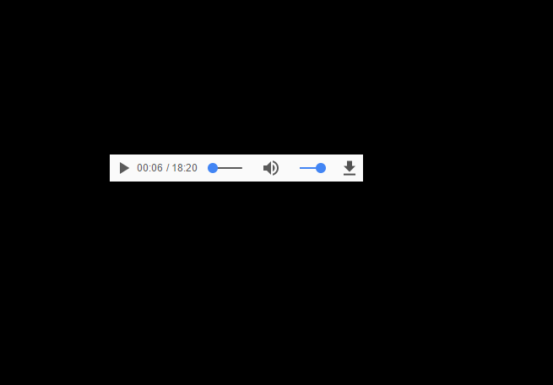

https://s3.amazonaws.com/unshakable/How+To+Apply+the+Gospel+Part+1.mp3
https://s3.amazonaws.com/unshakable/How+to+Apply+the+Gospel+to+Anyone%2C+part+2.mp3
https://s3.amazonaws.com/unshakable/Lessons+1-7/Psalm+22%2C+The+God+Forsaken+Son.mp3
https://s3.amazonaws.com/unshakable/Lessons+1-7/Isaiah+53%2C+is+God+a+Child+Molecher.mp3
https://s3.amazonaws.com/unshakable/Lessons+1-7/Romans+5%2C+Who+is+Included+in+Christ.mp3
https://s3.amazonaws.com/unshakable/Lessons+1-7/What+Was+Jesus+Doing+in+Hades+for+Three+Days.mp3
https://s3.amazonaws.com/unshakable/Lessons+1-7/The+New+Man+and+The+Faith+of+Jesus.mp3

https://s3.amazonaws.com/unshakable/Lessons+1-7/The+Ascension%2C+War+and+Mercy.mp3
https://s3.amazonaws.com/unshakable/Lessons+1-7/The+Enthronement+of+Christ%2C+Pentecost+and+Intercession.mp3
https://s3.amazonaws.com/unshakable/Bonus+Material/Faith+Project+Meditation.m4a
https://s3.amazonaws.com/unshakable/Bonus+Material/The+Judgment.mp3
https://s3.amazonaws.com/unshakable/OTO/The+Fathers+Perfect+Love+for+You.mp3
https://s3.amazonaws.com/unshakable/On+the+Incarnation+pdf/On+the+incarnation+by+St+Athanasius.pdf

The Teaching Notes:
https://images.clickfunnels.com/uploads/digital_asset/file/168891/Psalm_22__THe_God-Forsaken_Son__FOUNDATIONS_BIBLE_STUDY__Class_1__Ps_22__teacher_notes.pdf
https://images.clickfunnels.com/uploads/digital_asset/file/168901/Isaiah_53__Is_God_a_Child_Molecher.pdf
https://images.clickfunnels.com/uploads/digital_asset/file/168911/Romans_5__Who_is_Included_in_Christ.pdf
https://images.clickfunnels.com/uploads/digital_asset/file/168921/What_Was_Jesus_Doing_for_Three_Days_in_Hades.pdf
https://images.clickfunnels.com/uploads/digital_asset/file/168931/The_Faith_of_Jesus_Saved_You__Jesus_and_the_New_Man.pdf
https://images.clickfunnels.com/uploads/digital_asset/file/168941/The_Ascension__War_and_Mercy.pdf
https://images.clickfunnels.com/uploads/digital_asset/file/168951/The_Enthronement_of_Christ.pdf
https://images.clickfunnels.com/uploads/digital_asset/file/168961/The_Judgment.docx

